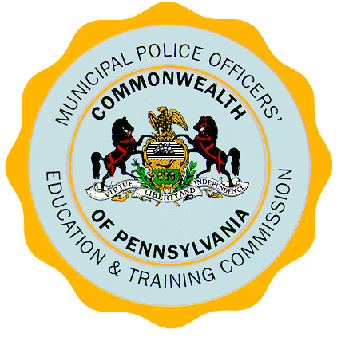
Commonwealth of Pennsylvania Telephone (717) 346-4086
Municipal Police Officers’ PA Only (800) 342-0858
Education and Training Commission
8002 Bretz Drive
Harrisburg, Pennsylvania 17112-9748

December 23, 2014

Dear Agency Head:

The purpose of this correspondence is to provide information and direction to police departments, or their municipalities, interested in requesting reimbursement for approved police training of their police officers who are Act 120 certified.

Reimbursements will be considered for successful completion of Continuing Law Enforcement Education (CLEE), commonly referred to as Mandatory In-Service Training (MIST) that took place during the 2014 calendar year. Reimbursements will also be considered for basic training tuition and salary for police officers who successfully completed the entire basic training program during the 2014 calendar year and were hired by the submitting agency prior to academy admission.

All requests for reimbursements will be processed by MPOETC and paid to police departments on a pro rata basis as determined by the eligibility of training and availability of funding.

The following timeline for submission of reimbursement requests will be strictly adhered to in determination of eligibility:

- Requests for reimbursements of CLEE/MIST must be submitted between
January 1, 2015, to February 28, 2015, for determination of reimbursement.

- Requests for reimbursement of basic tuition and salary must be submitted between March 1, 2015, to April 30, 2015, for determination of reimbursement.

The CLEE/MIST and basic training tuition and salary reimbursement request forms will be made available in the future at www.mpoetc.state.pa.us and may be mailed to the Municipal Police Officers’ Education and Training Commission, Attn: Administrative Unit, 8002 Bretz Drive, Harrisburg, PA 17112-9748, or submitted electronically to MPOETC’s resource account at RA-SPMPOFSS@pa.gov, by the specified due dates.

Each police department will need to verify they have a non-procurement vendor number registered with the Commonwealth of Pennsylvania by following the instructions at www.vendorregistration.state.pa.us. We will continue to provide additional information as it becomes available on the MPOETC website at www.mpoetc.state.pa.us.

Please contact the Municipal Police Officers’ Education & Training Commission at
(717) 346-4086 for assistance or additional information.

Sincerely,

Major Douglas E. Grimes
Executive Director

